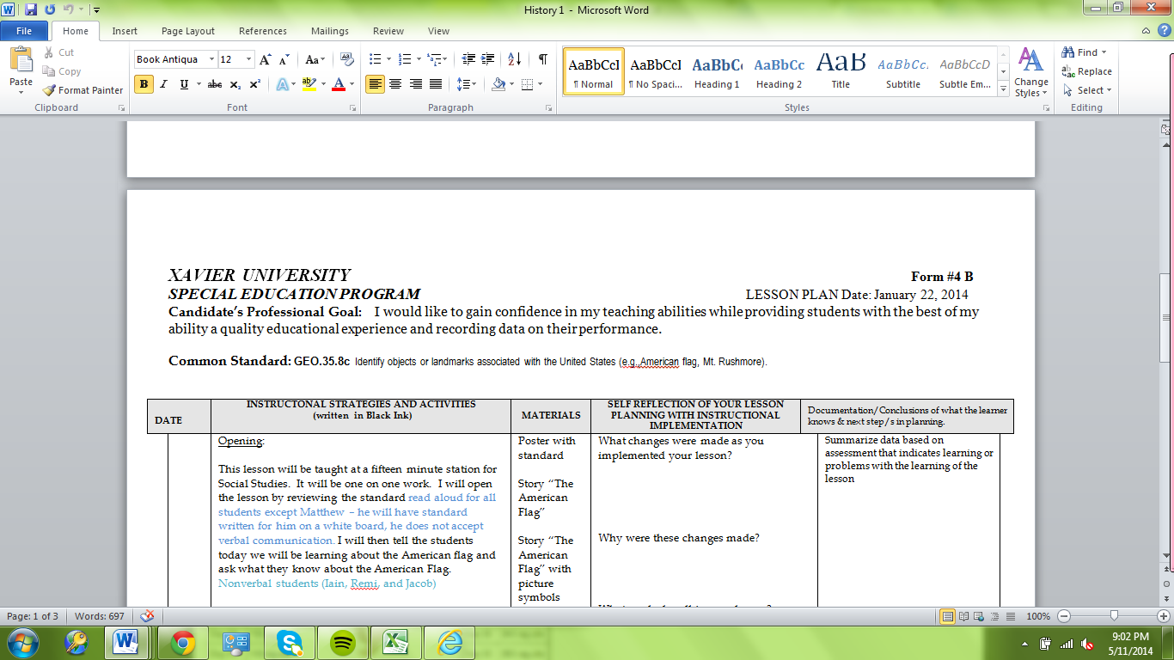

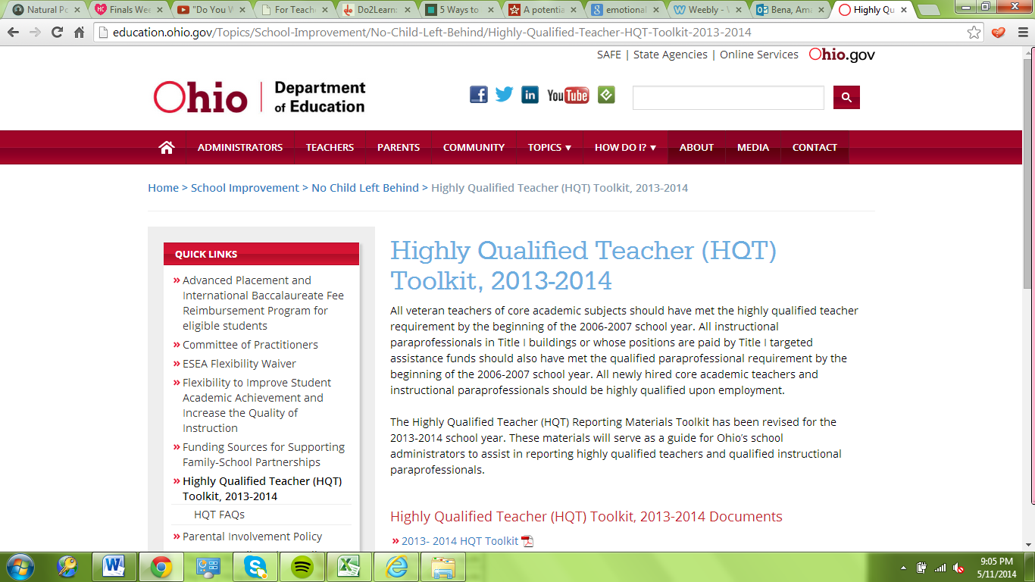

‘

Standard 7 Artifacts:
- At the top of every lesson was a professional goal. This served as a reminder to what I need to work on throughout every lesson.
- Throughout my student teaching placement we had frequent meetings on Highly Qualified Teaching. This helped me to develop professionally.

