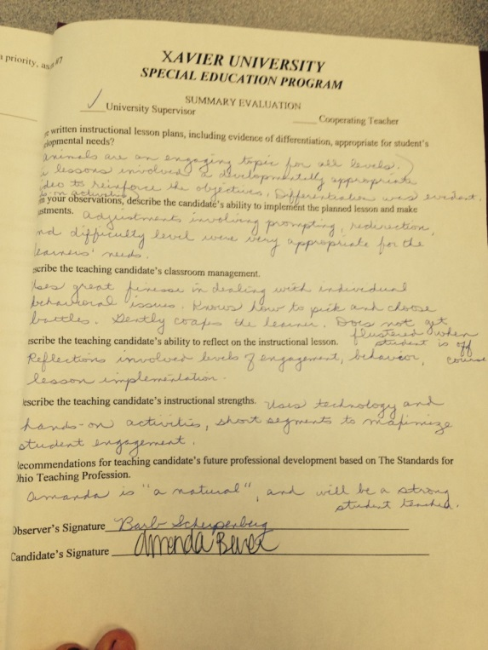
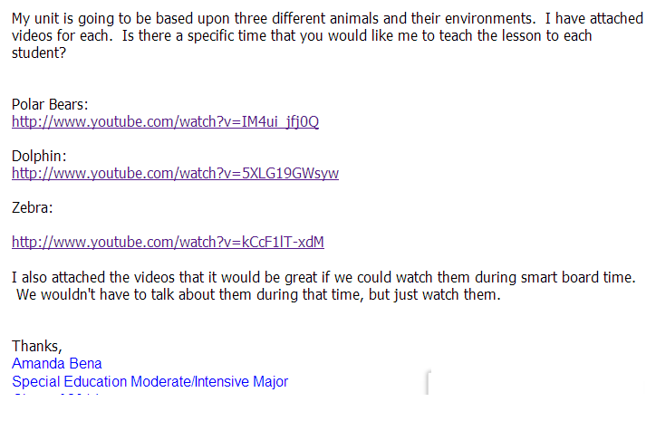
Standard 6 Artifacts:
- I collaborate effectively with other teachers administrators and school and district staff. The emails that were exchanged between my cooperating teacher and I were very professional and always were sent in a timely manner.
- I communicate and collaborate clearly and effectively with the Xavier staff. I took her comments that she made in my summary evaluation to heart and reflected on them.

asdf

