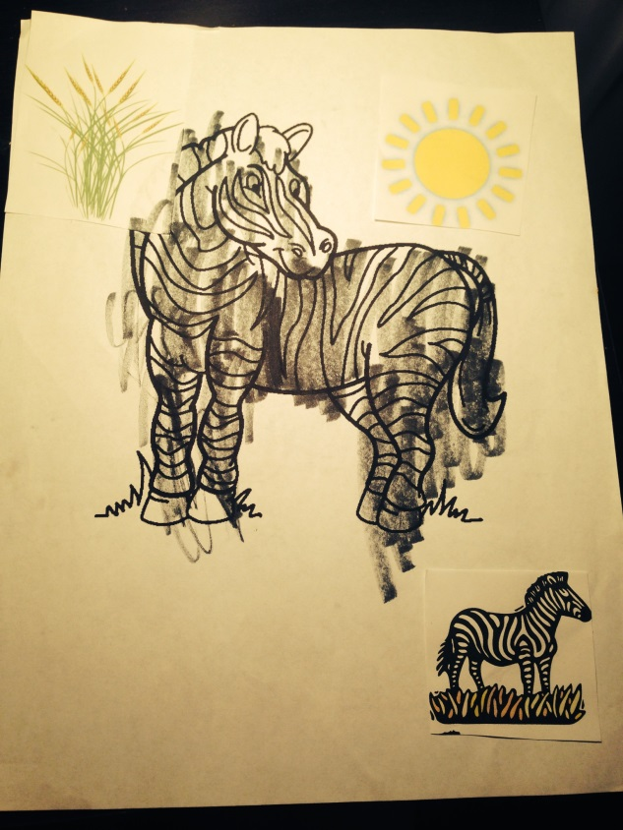

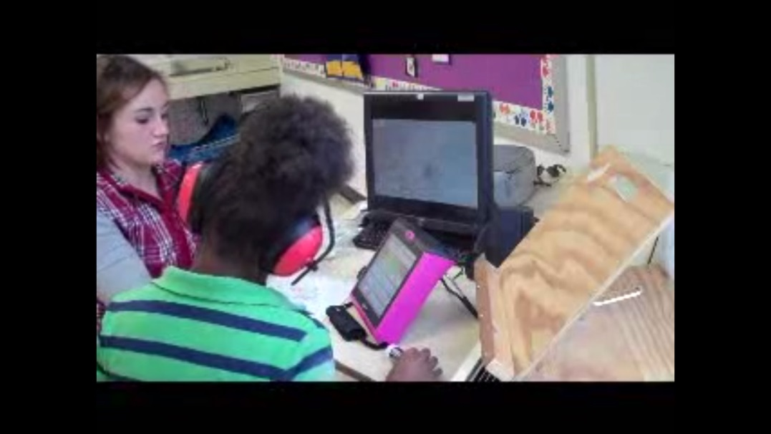

Standard 5 Artifacts:
- I maintained an environment that is conductive to learning for all students. Each student was able to hand in work that they did and they all showed that they knew the information. An example is shown below, a piece of work from a student about the zebra. She completed this independently.
- Also, I create learning situations in which students work independently, collaboratively and/or as a whole class. I decided to work with my two students individually. They receive plenty of time during the day of all class instruction. I thought that it was more beneficial for them to meet with me one on one.

asdfasdf

