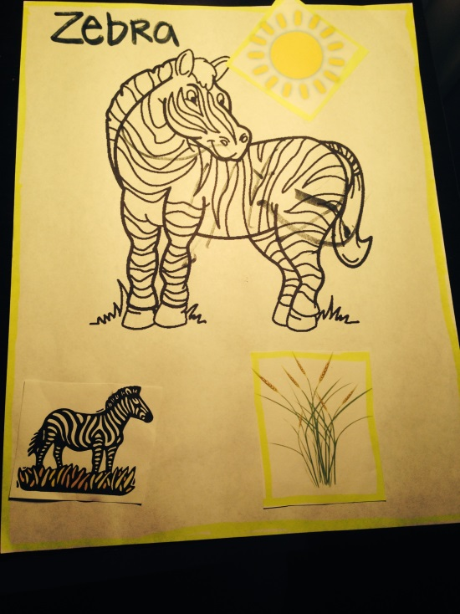

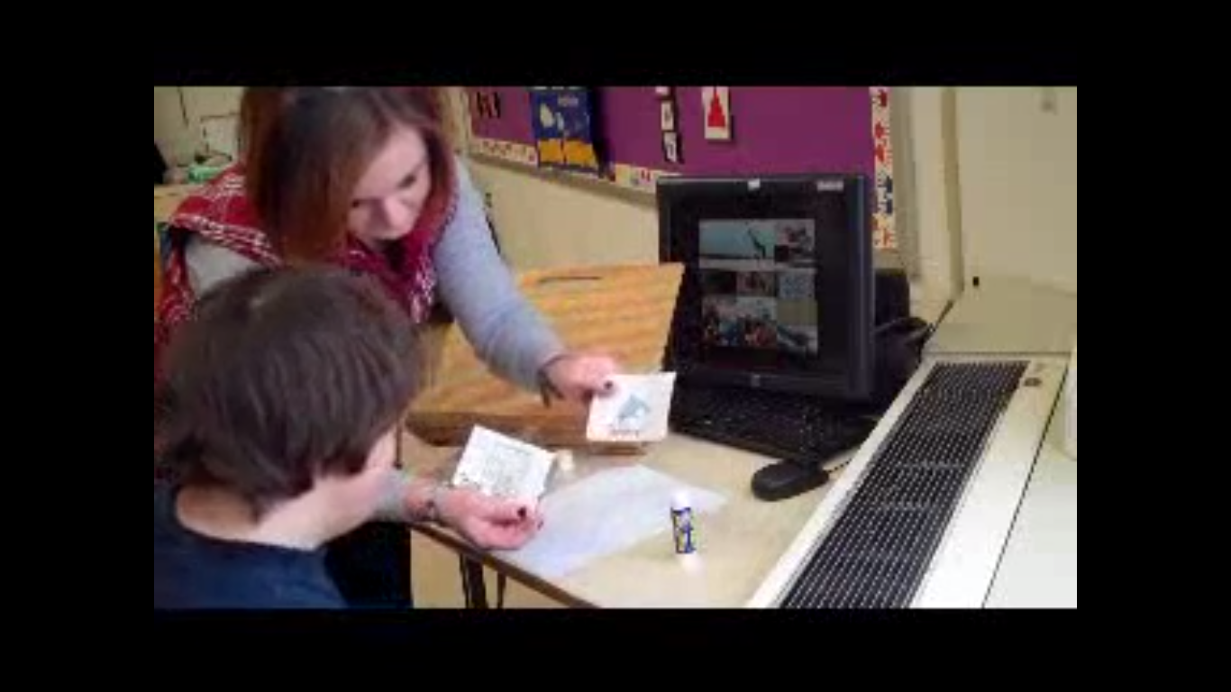

Standard 4 Artifacts:
- I differentiate instruction to meet the needs of all students, including gifted students, students with disabilities, and at-risk students. An example of this is shown with an assessment of a student. He has an IEP goal of color matching and I included it in his lesson.
- I use my resources effectively, including technology to enhance student learning. I learned through observation that the students used the Smart Board room once a week and really enjoyed technology. That is why I decided to add the computer and videos into my lesson.

