Standard 4: Candidates plan and deliver effective instruction that advances the learning of each individual student

Element | Reflection/Documentation
Candidates align their instructional goals and activities with school and district priorities and Ohio’s academic content standards | The instructional goals were based off of two main components: IEP goals, including functional and communication goals, and Ohio Extended Standards. Each lesson that was taught was accompanied by at least one Ohio Extended Standard goal and it was individualized to meet at least one of each student’s IEP goals. The goals that were being met were written on a white board that was located near the appropriate center.
Candidates use information about students’ learning and performance to plan and deliver instruction that will close the achievement gap | At the end of each day, I evaluated the students work and decided if we needed to work on more material relating to that subject, or if the student had proficiently mastered the material. The students were able to progress at speeds that were different from their classmates based on their proficiency levels in the topic area. This is due to the fact that the students spent most of their day working one on one with an instructor or an aide.
Candidates communicate clear learning goals and explicitly link learning activities to those defined goals | The clear learning goals were appropriately written at the top of each written lesson. The goals that were used related to the students IEP goals and the Ohio Extended Standards. The goal was briefly stated to the student, in simplest terms, at the beginning of the lesson so the student was aware of the learning target.
Candidates apply knowledge of how students think and learn to instructional design and delivery | One of my students had several difficulties with processing receptive language. Therefore, whenever I worked with this focus learner I made sure that I had all of the materials ready with pictures and written words. The way the student reacted to verbal language really depended on the day. Some days he was able to understand and respond to verbal language. However, there were other days where the focus learner was completely unresponsive to spoken word. I frequently used a simple communication device, in the form of a white board, to elicit responses from the student.  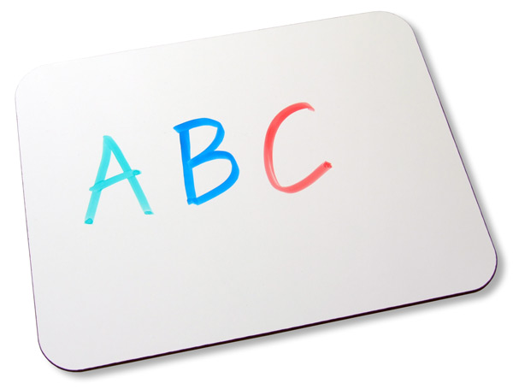
Candidates differentiate instruction to support the learning needs of all students, including students identified as gifted, students with disabilities and at-risk students. | Every student in my previous school was identified as having a disability, and every student was on an IEP. Instruction in the classroom was differentiated for every single student. At any given time, every student in the classroom could be working on a completely different assignment. This is due to the varied levels of learning in the classroom.
Candidates create and select activities that are designed to help students develop as independent learners and complex problem-solvers. | Although there was always one on one support for each student, as stated in their IEP’s, many of the students were encouraged to try the work first and then either verbally ask for help or use a gestural sign. The complexity of each lesson was focused on illuminating the focus learner’s strengths and improving their deficits.
Candidates use resources effectively, including technology, to enhance student learning | In the school that I was placed in for my student teaching experience I was fortunate enough to have endless materials at hand. The classroom was equipped with two iPad’s which were used at the technology center. Also, in the classroom a Tap-It interactive board was used. The board was used during center times with a visual timer and to play relaxing music. The board was used during our group lessons to show videos and to read interactive stories. Our morning group also incorporated the use of the Tap It board. The students would take turns going to the Tap It board and signing their name for the day, and deciding the weather.  