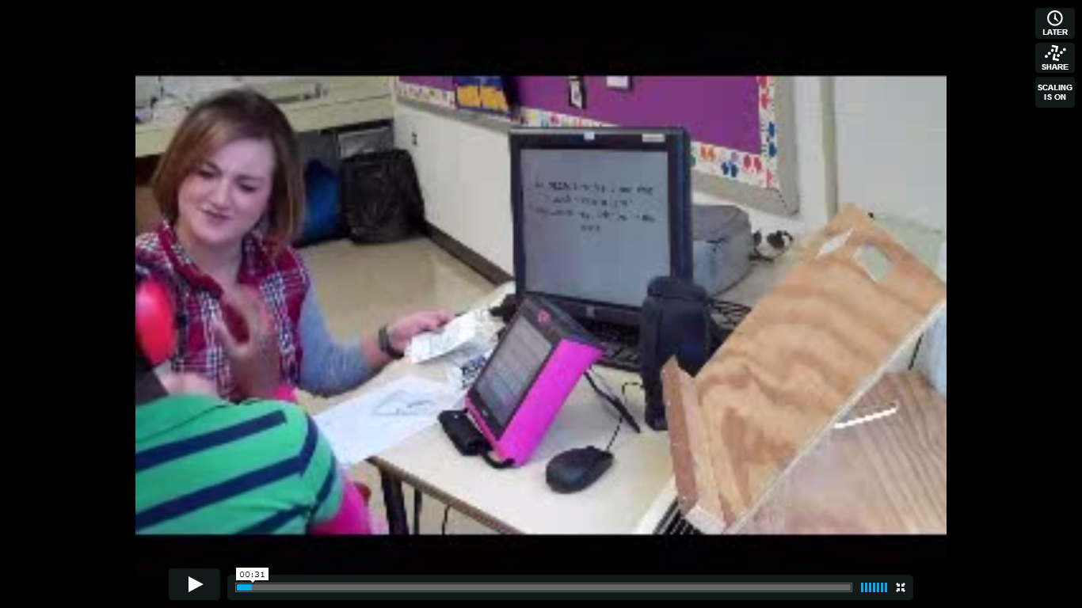

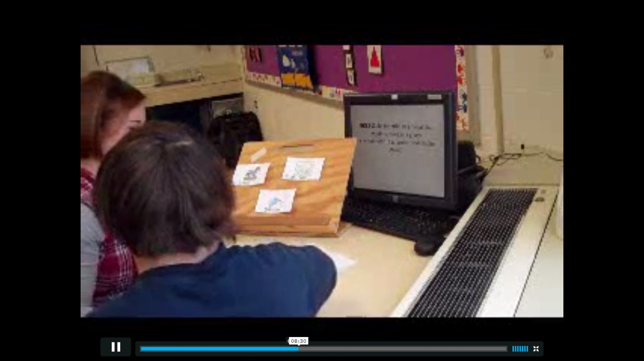

Standard 3 Artifacts:
- I collaborate and communicate student progress with students, parents and colleagues. I tell students how they are doing throughout the lesson and reward them by giving them high-fives.
- At the end of every lesson, I made it a point to ask the learner that I was working with if he or she enjoyed the lesson. For some of the verbal learners I was looking for a yes/no verbal response. However, for the non-verbal learners we used communication devices and simple gestural signs to understand and meet their needs. This helped me to determine whether or not the information they were learning about was something that interests them or not. If the students seemed to like an activity, I would create an activity that was similar to the one we just completed.

