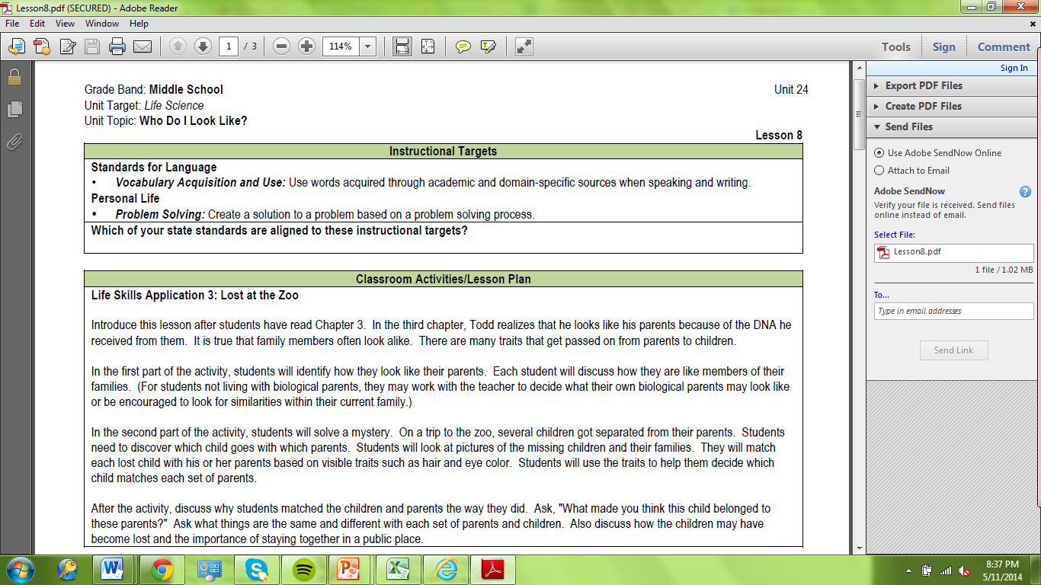

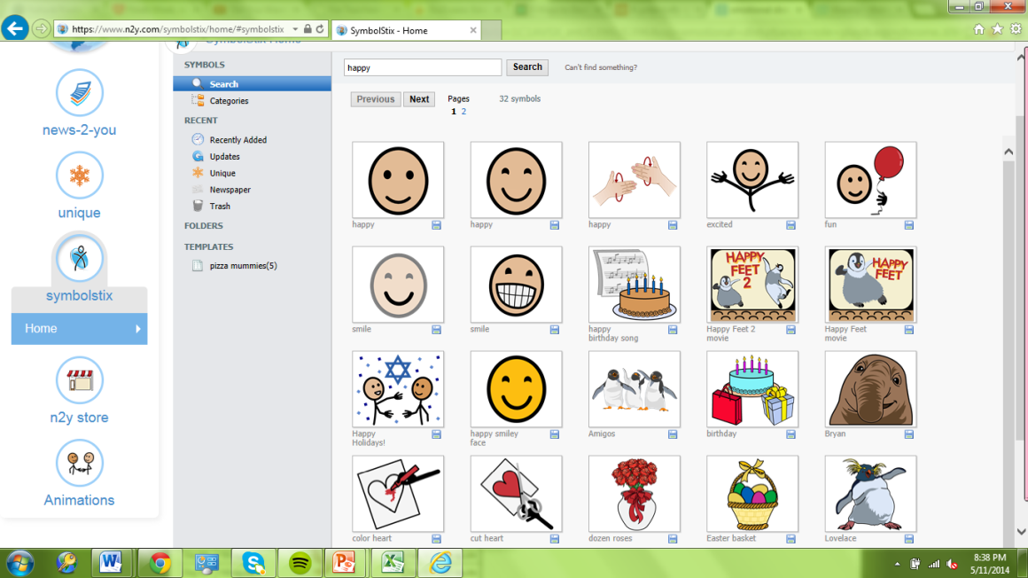

Standard 2 Artifacts:
- The first artifact shows a lesson plan that is from the Unique curriculum. Not only do the lessons incorporate educational goals, but they also incorporate life skills. This is important for the students on a daily basis.
- The second artifact shows SymbolStix which are visuals that represent words. The system is available for every student at school and is used frequently during the school day in the form of picture schedules etc.

