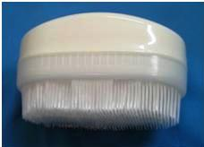

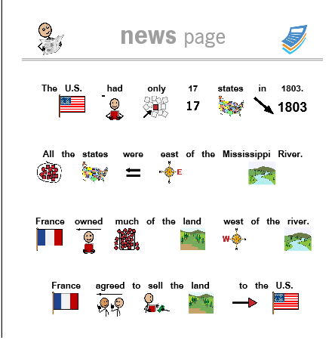

Standard 1 Artifacts:
- A sensory brush was used in the classroom. I understood that my students had a variety of sensory needs and throughout the day a sensory brush was used to calm the students and allow them to focus on their work. The sensory brushes were carried by all staff members in the classroom.
- Specifically designed curriculum with visual pictures were designed for each student. The system “New-2-You” allows each student to read with varied levels. This was implemented in the classroom every day.

